VMS Implementation Plan
Nov 6, 2026 · @wasath

Overview
The Visitor Management System (VMS) can go live about 13 weeks after the customer signs off SRS-2026-VMS-001, followed by 2 weeks of hypercare. Week 1 starts on the sign-off date.
- Scope: exactly the 29 functional and 11 non-functional requirements in the SRS. Anything added after sign-off is a change request.
- Approach: 8 phases, each ending in a demo to the customer. The guard room console ships to a staging server by week 7 so guards can try it early.
- Hosting: Docker on the DOK Solutions GCP server behind the shared Nginx, unless the client asks for its own server.
- Must-haves for go-live: pre-registration, guard check-in/out, walk-ins, guard-room data segregation, notifications, dashboard. Low-priority items (pass slip printing, overstay alerts, blacklist) can move to a phase 2 release if time is tight.

Tech stack and architecture
The stack is Next.js (React) for all three portals, NestJS with Socket.IO for the API and live events, PostgreSQL for data and Redis with BullMQ for pub/sub and the SMS/email queue — all as Docker containers on the shared GCP server.
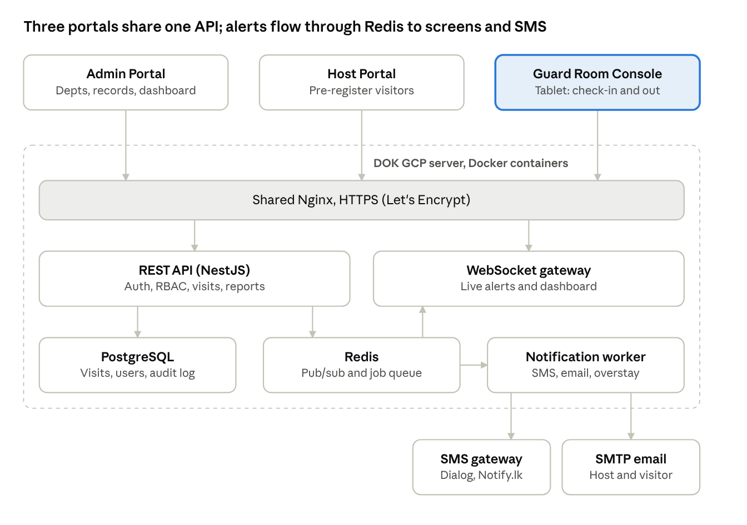
VMS architecture · 3 portals, 5 services, 2 external gateways
The guard console is the most-used screen, so it gets a tablet-first layout. Redis carries every visit event both to open screens (via the WebSocket gateway) and to the worker that sends SMS and email.

Phases and timeline
Eight phases run 15 weeks: 13 to go-live and 2 of hypercare, with a customer demo at the end of every phase.
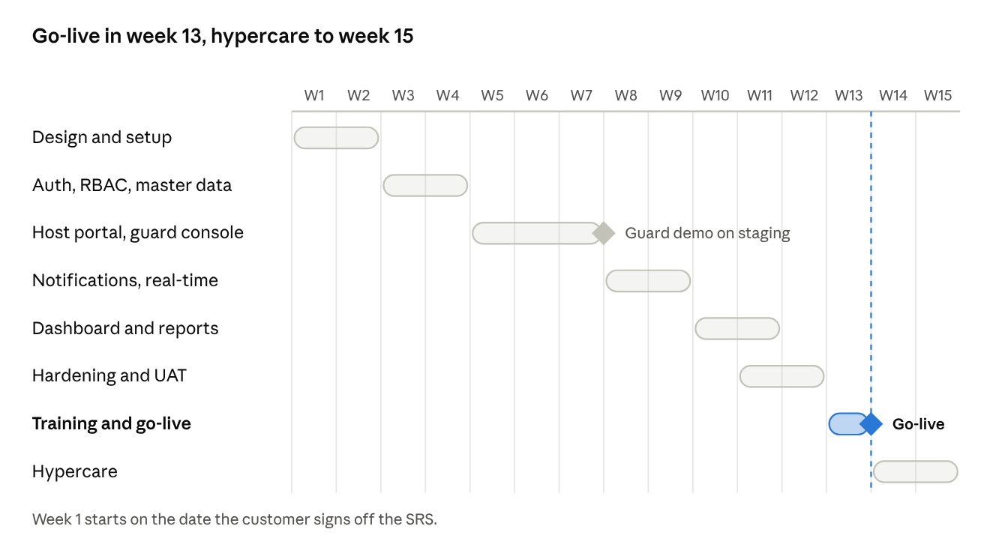
Delivery timeline · 7 phases over 15 weeks
The guard demo in week 7 is the key check: guards try the console on staging before notifications and reports are built, so layout changes are cheap.

Task breakdown
Modules are built in dependency order: nothing in the guard console works without users, guard rooms and RBAC.
# | Module | Key tasks | SRS refs | Weeks
1 | Project setup | Repo, CI/CD pipeline, Docker Compose, staging on GCP, coding standards | — | 2
2 | Auth & RBAC | Login, JWT sessions, 4 roles, server-side guard-room and department scoping middleware | FR-1, FR-17, NFR-3, NFR-5 | 3
3 | Master data | Departments, guard rooms (seed client's 3), users, guard assignment, pass categories (seed 5) | FR-2 to FR-6 | 4
4 | Host portal | Pre-registration form, group visitors, edit/cancel, "My visitors" list | FR-7 to FR-9 | 5
5 | Guard console | Expected today, search by NIC/name/ref, verify and edit on arrival, walk-in form, returning-visitor auto-fill, check-in/out, on-premises list | FR-10 to FR-16 | 5–7
6 | Notifications | Event bus, WebSocket alerts with sound, SMS and email workers with retry, notification log | FR-18 to FR-22 | 8–9
7 | Admin records | Search, sort, filter by date, guard room, pass type, company, department; department-admin view | FR-23, FR-24 | 10
8 | Dashboard & reports | Live widgets, trends, Excel/PDF export | FR-25, FR-26 | 10–11
9 | Extras | Pass slip print, blacklist warning, audit log viewer | FR-27 to FR-29 | 11
10 | Hardening | NIC masking, encryption at rest, backups, load test, security review | NFR-1 to NFR-11 | 11–12
The audit trail (FR-28) is built into the data layer from week 3, not added at the end, so every write is logged from the start.

Database schema
Ten PostgreSQL tables cover the SRS. visits is the core table; every report and dashboard widget is a query on it.
Table | Key columns | Notes
departments | id, name, is_active | Seed HR, IT, Security
guard_rooms | id, name, location, is_active | Seed the client's 3 guard rooms
users | id, name, email, phone, password_hash, role, department_id, guard_room_id, is_active | role = super_admin, dept_admin, host, guard
pass_categories | id, name, is_active | Seed VIP, Rest, Loading, Inter, Contract
visitors | id, full_name, nic_or_licence (encrypted), nic_hash, address, phone, company | nic_hash allows lookup without decrypting
visit_groups | id, host_user_id, purpose, created_at | Optional parent for group visits
visits | id, reference_no, visitor_id, group_id, host_user_id, department_id, guard_room_id, pass_category_id, purpose, area_visited, expected_at, time_in, time_out, status, source, remarks, created_by | status = expected, on_premises, checked_out, cancelled; source = pre_registered, walk_in
notifications | id, visit_id, recipient_user_id, recipient_phone, channel, event, status, attempts, sent_at | channel = in_app, sms, email
blacklist | id, nic_hash, reason, added_by, created_at | Checked on every NIC entry
audit_log | id, user_id, action, entity, entity_id, before_json, after_json, created_at | Append-only
Indexes on visits: (guard_room_id, status, expected_at), (department_id, time_in), (pass_category_id, time_in), and visitors.nic_hash. These match the guard console lists and the admin filters.

Notifications and real-time
Every visit change publishes one event; a WebSocket push reaches open screens in under 5 seconds (NFR-2), and SMS/email go through a queue so a slow gateway never blocks a guard.
Event | Admin | Host | Assigned guard room | Visitor
Visitor pre-registered | In-app (+ email optional) | — | In-app alert with sound | SMS + email: ref no, date, guard room, host
Pre-registration edited / cancelled | In-app | — | In-app alert | SMS if date or guard room changed
Walk-in added | In-app | In-app + SMS | — | —
Visitor checked in | Dashboard update | In-app + SMS | — | —
Visitor checked out | Dashboard update | In-app (optional) | — | —
Overstay at cut-off time | In-app | — | In-app alert | —
Blacklisted NIC entered | In-app + email | — | Warning on screen | —
- Rooms: each socket joins guardroom:<id>, dept:<id>, user:<id> and admins, so a guard only ever receives events for their own guard room (FR-17).
- Delivery: a BullMQ worker sends SMS and email, retries 3 times with back-off, then marks the row failed in the notifications table for admins to see.
- Reconnect: on reconnect, screens re-fetch their lists, so nothing is missed during a network drop.

Testing, UAT and go-live
Go-live happens only after the customer signs the UAT sheet; each of the 6 use cases in the SRS becomes a UAT script.
- Developer testing (ongoing): unit tests on services, API tests for every role, with a test that each guard role cannot read another guard room's visits.
- System testing (weeks 11–12): full flows on staging, load test of 50 concurrent users and 200 check-ins per hour, security scan (OWASP ZAP), backup and restore drill.
- UAT (week 12): client admin, 1 host per department and 1 guard per guard room run UC-1 to UC-6 on staging with real SMS.
- Training (week 13): 1-hour session for admins and hosts; 30-minute hands-on session at each guard room; 2-page quick guide for guards.
- Go-live (end of week 13): production deploy, seed master data, create users, pilot at 1 guard room for 2 days, then all 3.
- Hypercare (weeks 14–15): daily check of failed notifications and errors, fixes within 24 hours.
- ☐ UAT sign-off by client
- ☐ SMS gateway sender ID approved
- ☐ Guard room devices tested on site
- ☐ Production backups verified

Team, risks and open questions
A team of 4 can deliver this in 13 weeks.
Role | Allocation | Focus
Tech lead | 50% | Architecture, RBAC, reviews, deployment
Backend developer | 100% | APIs, notifications, workers, reports
Frontend developer | 100% | Host portal, guard console, admin dashboard
QA / BA | 50% | Test cases, UAT scripts, training material

Risk | Impact | Mitigation
SMS gateway account or sender ID approval is late | Visitor and host SMS cannot be tested | Request it in week 1; in-app and email work meanwhile
Guard room internet is unstable | Check-ins fail at the gate | Test on site in week 7; recommend 4G backup router; clear retry on screen
Scope grows after sign-off (e.g. ID scanning, photos) | Timeline slips | Log as change requests with new version of the SRS
Guards find the console hard to use | Low adoption, paper logs continue | Tablet-first UI, early guard demo in week 7, on-site training
NIC data handling under the PDPA | Compliance exposure | Encryption, masking, retention policy agreed with client
Open questions for the client
- ☐ Names and locations of the 3 guard rooms
- ☐ Which SMS gateway (Dialog, Mobitel, Notify.lk or the client's own)?
- ☐ Host or self-hosting on the client's server?
- ☐ Can a visitor leave from a different guard room than they entered?
- ☐ What does each pass category allow (e.g. which areas for a Loading Pass)?
- ☐ Overstay cut-off time and data retention period
- ☐ Should guards capture a visitor photo or vehicle number?

